**ROBOTICS Project**

Coordinator Professor: Trăsnea Bogdan

Name: Avasiloaie Stefan

Study Program: AUTOMATICA

Group: 4LF411 Year: 2022-2023

INTRODUCTION:

• Initially, I didn't have many ideas for this project, so I decided to get inspiration from the internet.

• I found this robot idea, more precisely:

• - a robot that avoids obstacles using a proximity sensor

• I really liked the idea and started researching it to know exactly what I need.

ROBOT ARCHITECTURE:

• Robot Kit 2WD UNO N4

• - UNO R3 development board

• - 2WD robot chassis

• - 2x Rubber tire wheels

• - 2x 5V DC Gear Motors

• - Assembly parts (screws, nuts, plates)

• - L298N motor driver module

• - HC-SR04 ultrasonic sensor

• - Dupont cables

• - External battery

**COMPONENTS:**

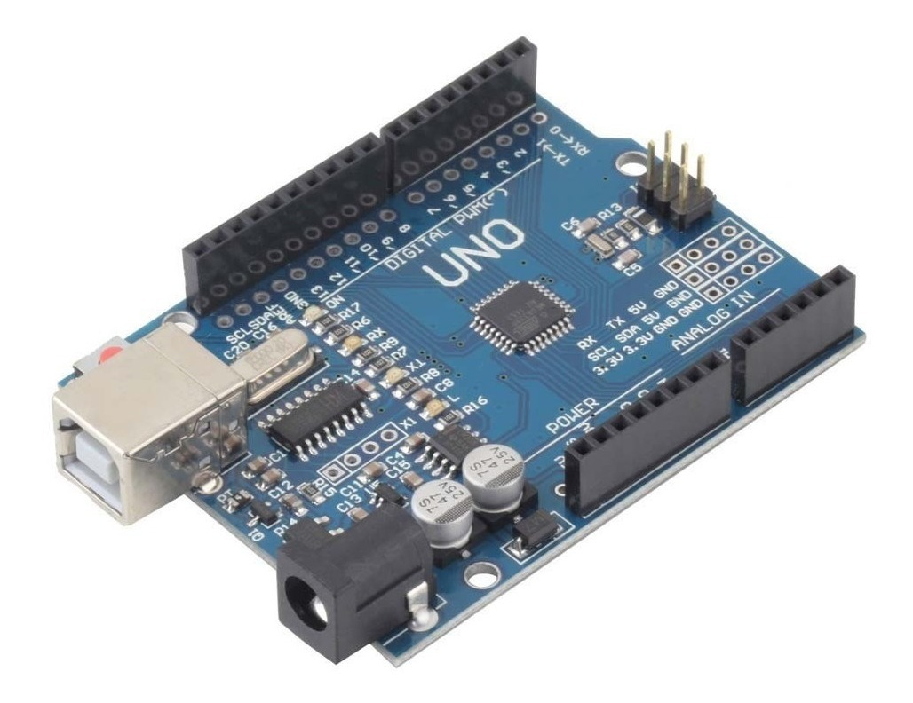

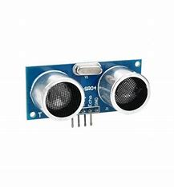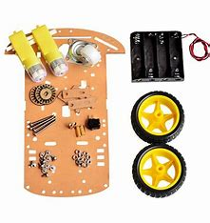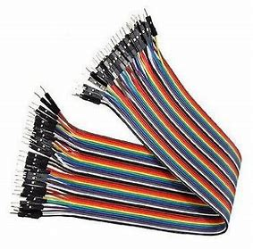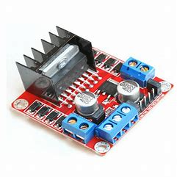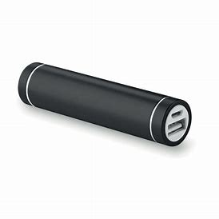

**CONECTION DIAGRAM:**

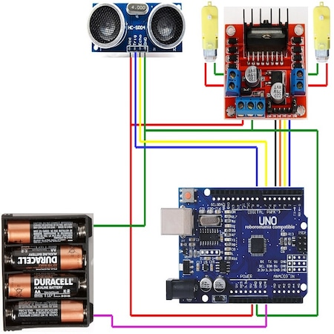

**ROBOT ASSEMBLY:**

• I didn't encounter many problems during the assembly process. With a lot of patience and testing, I managed to make all the connections between the components and write a code to make the robot work.

• For the assembly, I used a soldering iron, a set of screwdrivers, double-sided tape, and thread.

**CODE:**

|  |
| --- |
| ***ARDUINO*** |
| #include <NewPing.h>  #define TRIG_PIN 8  #define ECHO_PIN 7  #define MAX_DISTANCE 400  #define COLL_DIST 15 // distanta de coliziune la care robot stop si inapoi este de : 15cm  NewPing sonar(TRIG_PIN, ECHO_PIN, MAX_DISTANCE);  #define SPEED 10  // L298n module  // 1(+)inainte dreapta = DrFr  // 2(+)inapoi dreapta = DrSp  // 3(+)inainte stanga = StFr  // 4(+)inapoi stanga = StSp  int DrFr = 3;  int DrSp = 2;  int StFr = 4;  int StSp = 5;  void setup() {  Serial.begin(9600);  pinMode(DrFr,OUTPUT);  pinMode(StFr,OUTPUT);  pinMode(DrSp,OUTPUT);  pinMode(StSp,OUTPUT);  digitalWrite(DrFr,LOW);  digitalWrite(StFr,LOW);  digitalWrite(DrSp,LOW);  digitalWrite(StSp,LOW);  }  int scan() {  return (sonar.ping() / US_ROUNDTRIP_CM); //masurare distanta in cm  }  void loop() {  int Dist = scan(); // masuram distanta curenta  // Serial.println(Dist);  if ((Dist < COLL_DIST) && (Dist > 0)) { // daca distanta curenta < decit distanta de coliziune  moveStop();  moveBackward();  delay(500);  turnRight();  delay(300);  } else {  moveForward();  }  }  void moveStop() {  digitalWrite(DrFr,LOW);  digitalWrite(StFr,LOW);  digitalWrite(DrSp,LOW);  digitalWrite(StSp,LOW);  }  void moveForward() {  digitalWrite(DrFr,HIGH);  digitalWrite(StFr,HIGH);  digitalWrite(DrSp,LOW);  digitalWrite(StSp,LOW);  }  void moveBackward() {  digitalWrite(DrFr,LOW);  digitalWrite(StFr,LOW);  digitalWrite(DrSp,HIGH);  digitalWrite(StSp,HIGH);  }  void turnRight() {  digitalWrite(DrFr,LOW);  digitalWrite(StFr,HIGH);  digitalWrite(DrSp,HIGH);  digitalWrite(StSp,LOW);  }  void turnLeft() {  digitalWrite(DrFr,HIGH);  digitalWrite(StFr,LOW);  digitalWrite(DrSp,LOW);  digitalWrite(StSp,HIGH);  } |

**FINAL ASSEMBLY:**



I will attach a video from the moment I finished the code and connected all the components.

After this video, I only had to do the presentation, positioning, and attaching the components to the chassis."